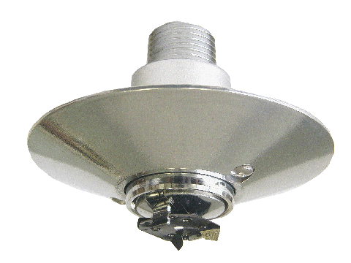
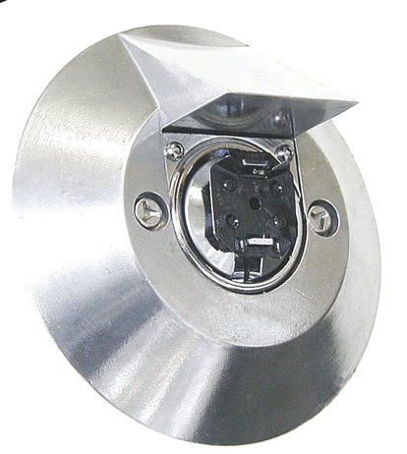

Engineering Specification
Model XL Institutional Sprinkler

Institutional sprinklers shall be [UL Listed] [NYC MEA Approved] quick response, [pendent, standard coverage sprinklers approved for light and ordinary hazard] [horizontal sidewall sprinklers, standard coverage, approved for light and ordinary hazard] [pendent, extended coverage sprinklers approved for light hazard] [horizontal sidewall, extended coverage sprinklers approved for light hazard]. Sprinkler and deflector to be of bronze construction, with ½” NPT thread. Levered fusible solder link shall consist of an approved black-painted beryllium-nickel link assembly. Fusible link shall be designed to release a suspended load that exceeds 50 lbs. (22.7 kg) when dropped from a 1-inch (25.4 mm) height. Water seal shall consist of a Teflon-coated Bellville spring washer and bronze diffuser sub-assembly containing no plastic parts. Institutional escutcheons shall be of zinc or aluminum construction with zinc ring plate and tamper resistant screws. Sprinkler K-factor shall be nominal 5.6 (81.0) . Sprinkler temperature rating shall be Ordinary 165 °F (74 °C). Standard cover finish: [Bright chrome plated] [Specialty – specify]. Quick response institutional sprinklers shall be Reliable Model XL Institutional [Pendent, Standard Coverage (SIN R1314)] [Pendent, Extended Coverage (SIN R1344)] [Horizontal Sidewall, Standard Coverage (SIN R1334)] [Horizontal Sidewall, Extended Coverage (SIN R1364)] Bulletin 113.

